CS 255 Business Requirements Document
DriverPass System
Prepared from the DriverPass interview transcript and schedule discussion.

Purpose

- DriverPass is creating a new system for their driver's education program that will help students pass their DMV written exam and their driving test.

- This new system is intended to combine all aspects of driver education (classes, practice tests, road lessons) into one streamlined solution.

- The system will serve multiple groups (management, IT staff, office staff, and customers) and provide information that allows DriverPass to provide better customer service, better organized training programs, and reduce the number of students who fail their DMV examination if they complete only old tests.

System Background

- DriverPass has created this service due to the number of students who fail their driving tests even if they've studied for the test multiple times

- Classroom-style education, Practice Tests, and Driving Lessons will be integrated into one service for DriverPass customers.

- Customers will have access to Practice Materials/Scheduling, and Office Staff will have the ability to Register Customers, and Schedule Appointments.

- The services will include: Web Interface, Cloud-hosted Application Services, Secure Database, Reporting, Scheduling Logic, User Account Management, Practice Test Content, and a Link to DMV Updates.

Objectives and Goals

Customers will have the ability to access the internet for on-line testing in addition to receiving on-line classes and practice exam materials that match the current requirements of the DMV and current type of test question.

Customers and employees may schedule, cancel and change driving lessons while tracking which driver, the car being used, the date and time of the lesson.

The packages will be handled on a package based format starting with three initial packages and providing the ability for management to deactivate a package from future registration.

There will be a means to track each customer's progress through test records, lesson records and driver notes.

Management and IT will have the ability to review reports, track activities and manage accounts.

Reports and selected information may be downloaded for off-line use in formats such as Excel.

Requirements

Nonfunctional Requirements

Performance Requirements

The system must be operated and accessed as a cloud application over the web from both desktop and mobile devices via internet browser(s).

Typical routines including logging in, viewing schedule information, loading progress data, and opening reports should have an expected response time or complete in seconds under normal conditions.

The system must be able to accommodate multiple users, including customers and internal staff, simultaneously.

DMV content updates should appear in the system immediately upon receipt of new rules/policies/sample questions.

Cloud technologies will be utilized to facilitate scheduled/periodic backups, uptime monitoring, and routine platform maintenance to minimize local technical support/overhead.

Platform Constraints

• According to DriverPass, the solution must be available via the web and not have to be installed locally. This allows DriverPass to access the solution from any computer or mobile device.

• DriverPass will not be responsible for the local backup and security of the system; therefore, the system must reside in the cloud.

• A back-end database of users, packages, reservations, lesson records, drivers, vehicles, practice test results, audit logs and report data will be required to store and maintain this information.

• To use the live system, Internet access will be required since no data should be modified if it has not been online at the same time; otherwise, there may be duplicate or conflict records created.

Accuracy and Precision

• User role distinctions should exist, such as owner, IT officer, secretary, customer and driver for all roles.

• An accurate match on all scheduled reservations to each customer, package, driver, vehicle and time slot must occur when scheduling each reservation in the system.

• All required data inputs must be validated in the system by name (first name and last name), address, phone number, state, payment type (credit card or debit card), pickup and drop-off locations and lesson start time.

• Each driving lesson must be two hours long to comply with all packages selected by the customer and generate the total amount of time purchased in this type of product by the customer's selected lesson package.

• Alerts should be sent to administrators whenever there is a scheduling conflict, failed update, invalid payment entry or suspicious account activity.

• Request status should remain consistent for practice tests, as defined for each request: not taken, in progress, failed, or passed.

Adaptability

A system needs to permit IT employees to create, alter, reset or deactivate user accounts without modifying any of the programs. Management also has the ability to disable an older package so that new customers cannot sign up for the package, however, they will still maintain an accurate historical record on file for any customer who was previously registered in that package. The system must be capable of updating any content associated with DMV without having to perform a complete redesign of the program. The deployment via the cloud should provide centralized maintenance as well as security patches and system upgrades while creating little or no interruption to users. The creation of completely new package modules and the introduction of other major structural modifications should be implemented as new enhancements upon the completion of the project and not included with the initial release.

Security

A valid user account must be provided to allow internal personnel & customers are granted access to the system. All users will only have access to perform their work functions using the role-based Access Control Model.

Sensitive data (Passwords, Credit Card) shall be encrypted during transmission and securely stored once the data is at rest.

The user's account shall be locked after the user has attempted a number of unsuccessful attempts to log in and shall notify an administrator of the occurrence for review, to reduce the risk of brute force attacks.

The IT security officer shall have the ability to reset passwords, unlock accounts and disable access to the system for users who are no longer employed by the company.

The customers shall have a method for securely resetting passwords if the passwords are to be forgotten.

There shall be an audit trail of all the account/reservation changes.

Functional Requirements

• Users (customers and internal staff) will be created and maintained by the system.

• Login credential validation will be completed by the system.

• The IT Officer will be able to manage account access by resetting passwords and blocking users.

• Office staff will be able to create a customer account by entering contact information, state, financial information, and pickup/drop-off location.

• Customers will be able to log into the system and schedule, cancel, and change their own driving lesson(s) from the internet.

• The secretary will be able to assist customers in scheduling, cancelling, and changing their driving lesson reservations.

• Each customer's driving lesson reservation will have a driver and vehicle assigned to it.

• Each driving lesson must be scheduled in two-hour increments and the number of hours remaining for a package will be recorded.

• The system will inform customers of all available training package types and will save their selection.

• Management will have the ability to disable a training package from being registered for again in the future.

• Eligible customers will have access to all online classes and practice tests from that location.

• The system will provide the customer information on their progress while taking an online test, including test name, elapsed time, and score.

• Driver notes will be recorded and displayed for each scheduled lesson.

• Reports and activity logs will have the ability to be downloaded.

• The system will record which user created, cancelled, or modified each reservation.

• The system will receive updates to all DMV regulations, DMV policy updates, and update all sample questions as received to driverpass.com.

• The system will have a contact page, allowing staff to contact each customer.

User Interface

The user will be able to access the interface via an internet-connected computer (Web browser) as well as via a mobile device.

The user dashboard should include the following information: Lesson Reservations, Packages, Online Class Access, Progress on Practice Tests, and Driver Notes.

The secretary will require an input form (to register customers) and an interface for making/receiving phone or walk-in reservations.

The owner and IT officer will require administrative screens for Reports/Statements, User Management, Audit Tracking, and Package Control.

The Online Test Progress page will display the following: Test Name, Time Taken, Score (points), and Status (Completion).

The Lesson Notes page will display the following: Lesson Time, Start Time, End Time, and Driver Comments.

Navigating through the Interface will be facilitated via easy to read and easy to use clear labels so that users know how to register, schedule, view their progress and/or request for assistance.

Assumptions

- Customers must have internet access and a compatible web browser in order to access the DriverPass online system.

- DriverPass will keep accurate records for drivers, vehicles, package availability, and lesson capacity.

- A car is tied to a driver as discussed previously in Section 1 of the Interview.

- A payment system or some alternative way of processing payments will be available at the time a customer is registering with DriverPass.

- The DMV will provide a method (other than email) by which to receive timely updates regarding any new DMV rule and/or any availability or example questions.

- Customers will be set up with an account before they can utilize the online scheduling features, if they initially register using the DMV office.

- DriverPass employees shall be trained on how to use the administrative functionality of the DriverPass program.

Limitations

The system cannot support live data edits while offline since this will result in duplicates or conflicted records.

There will not be a custom package builder for non-customers at the first release; development of new modules or redesigns of existing packages will come later.

The system needs internet connection, cloud availability, and the DMV allows for updates outside of the DMV by an outside source.

The number of cars, drivers, and available lesson times limits how many scheduling slots are available in the system.

The system design uses an interview's description of 3 packages & 2-hour lesson structure as guidelines.

Access to the internet allows easier access to the system, however, persons without internet access will still need to contact an employee by phone or in person to schedule.

Gantt Chart
The schedule below follows the dates and dependencies described in the DriverPass interview transcript.
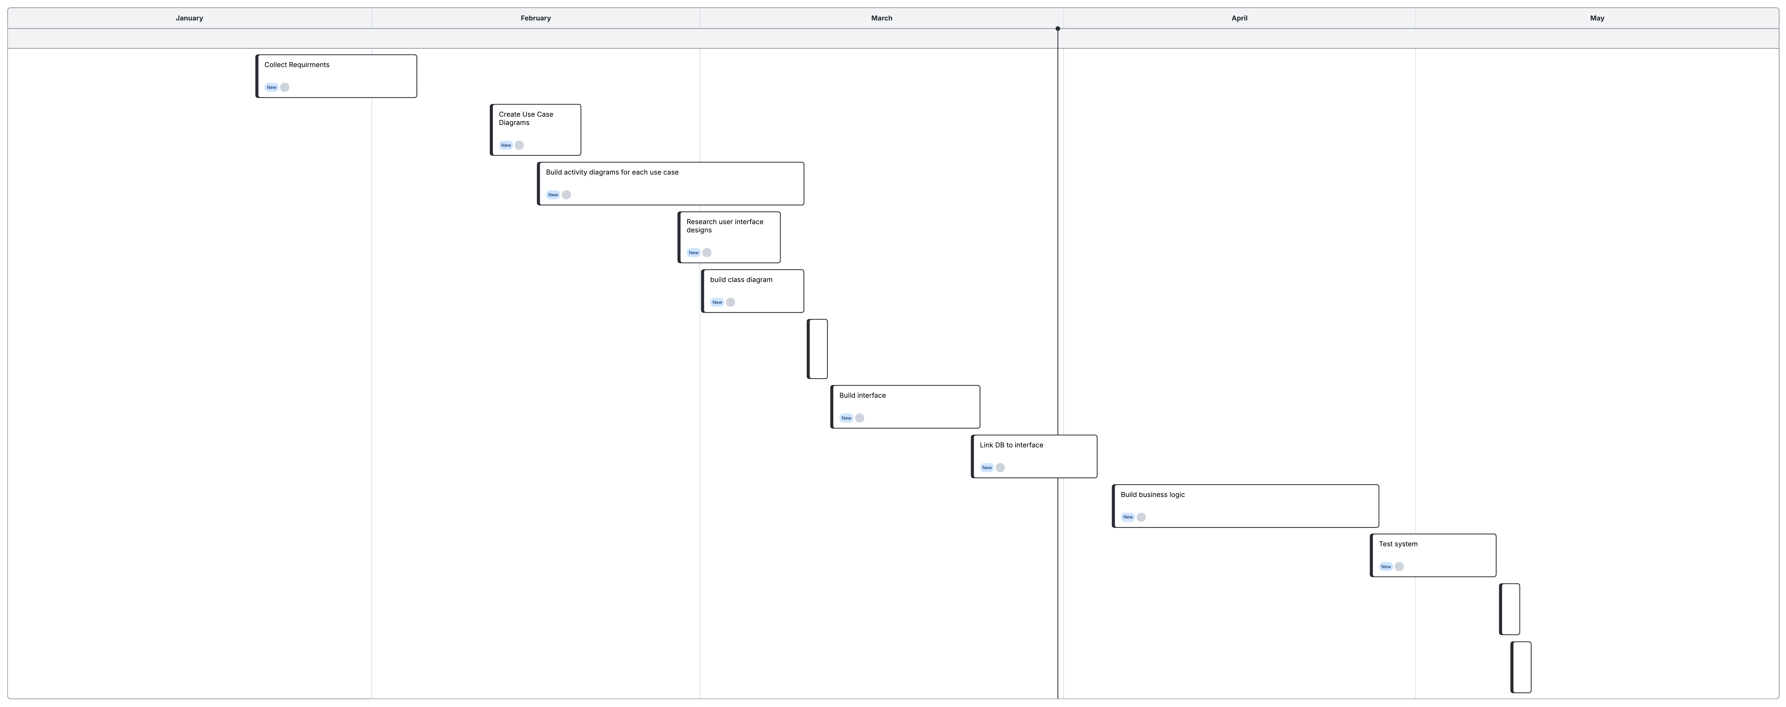
Figure 1. DriverPass project Gantt chart based on the interview schedule.

